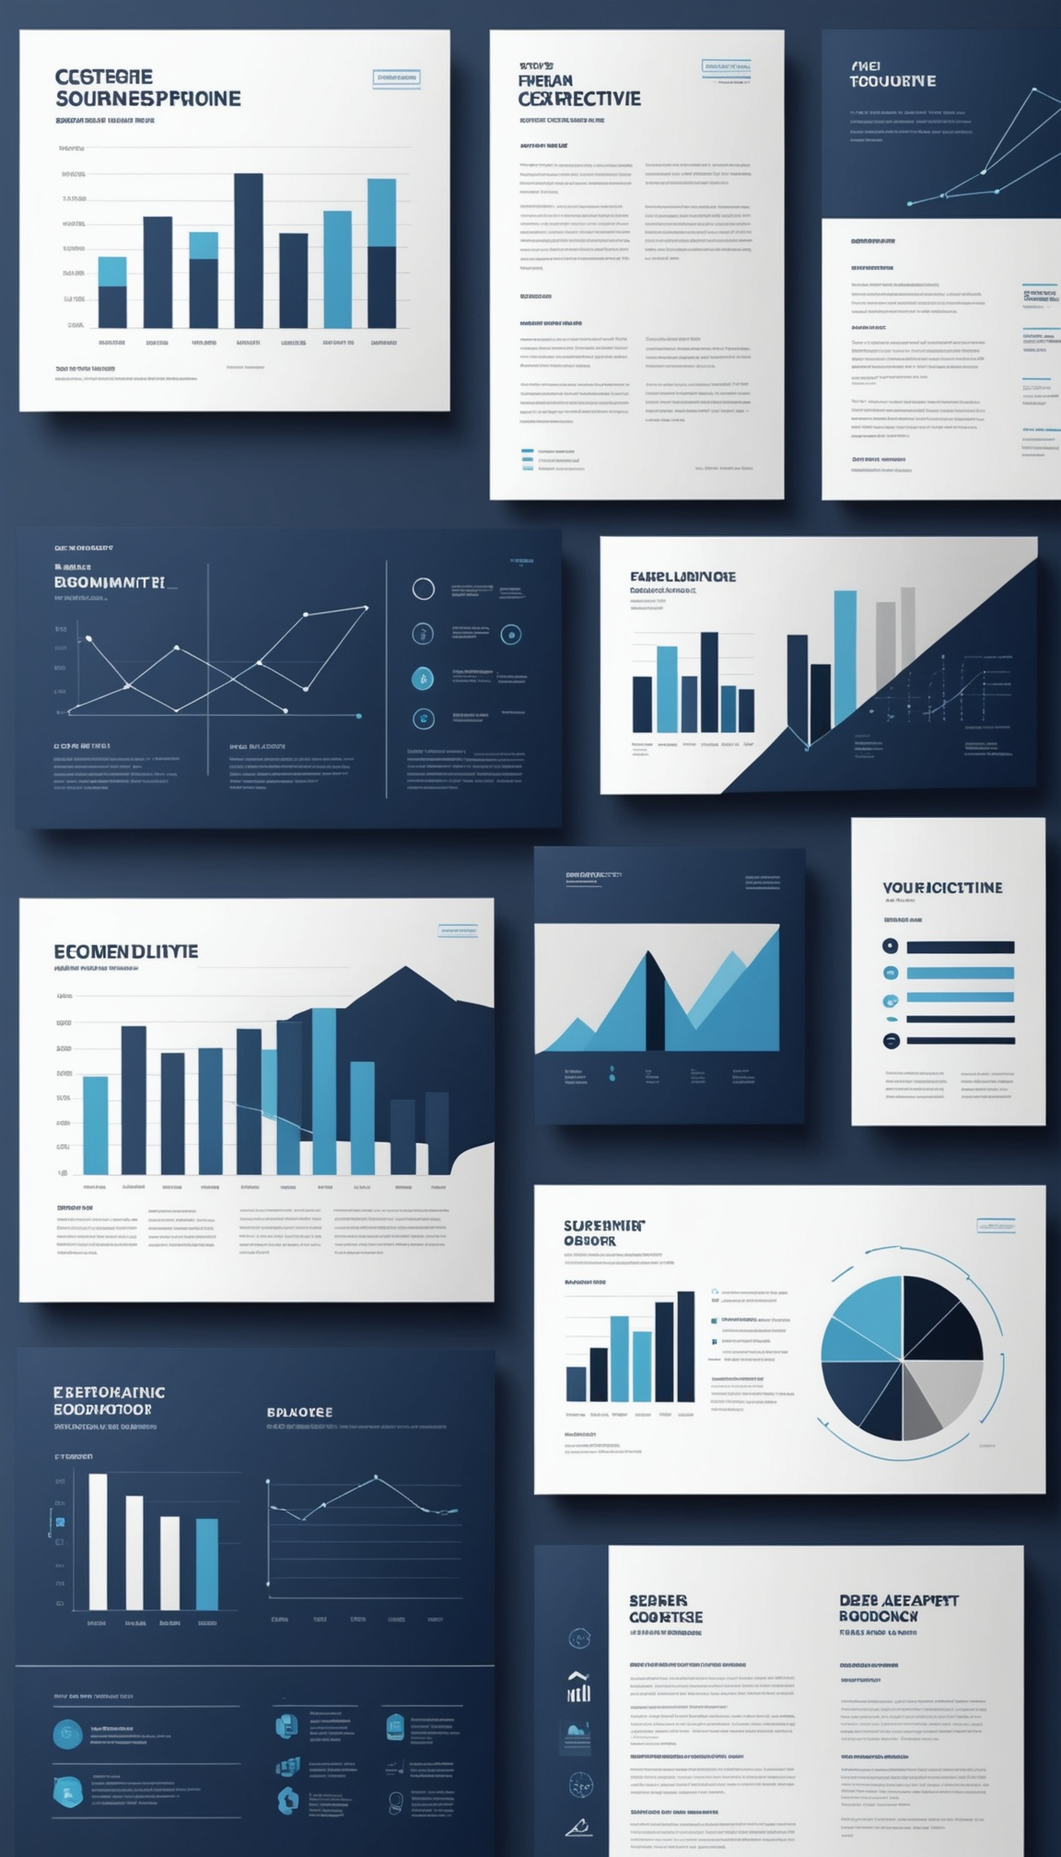
Executive Summary
Quarterly Board Briefing
Q3 FY2026

Business Highlights
- Total quarterly revenue reached $10.4M, up +12% YoY, driven by strong performance across all three business segments.
- Product Sales remained the largest contributor at $5.2M, reflecting sustained demand in core markets.
- Services revenue grew to $3.8M, supported by expanded client engagements and renewal rates.
- Licensing revenue contributed $1.4M, with new partnership agreements signed during the quarter.
- Operational execution remained on track against board-approved milestones, with no material delivery slippage.

Financial Snapshot

Metric | Value
Total Revenue | $10.4M
Revenue — Product Sales | $5.2M
Revenue — Services | $3.8M
Revenue — Licensing | $1.4M
Net Profit | $2.1M
Net Margin | 20.2%
Cash Reserves | $8.6M
Revenue Growth (YoY) | +12%

The quarter closed with a 20.2% net margin, reflecting disciplined cost management alongside continued top-line growth. Cash reserves of $8.6M provide a healthy liquidity buffer to support planned strategic investments in the coming quarter.

Strategic Priorities

1. Accelerate Services segment growth through expanded enterprise account coverage and renewal automation.

2. Scale Licensing partnerships into two additional verticals identified during Q3 market analysis.

3. Continue disciplined cost control to protect and extend the current 20.2% net margin.

4. Advance the technology roadmap to support product differentiation heading into next fiscal year.

5. Strengthen talent pipeline in key growth functions ahead of planned market expansion.

Risks & Outlook
- Macroeconomic sensitivity: Continued monitoring of demand elasticity in core Product Sales markets.
- Talent retention: Competitive hiring environment in growth functions poses execution risk to strategic priorities.
- Concentration risk: Licensing revenue remains reliant on a small number of key partnerships.
- Outlook: Management expects continued revenue growth next quarter, with net margin holding near current levels assuming stable input costs.
- Board is asked to note progress and approve continued investment allocation toward Services and Licensing expansion.

